[**https://www.orfonline.org/expert-speak/pavna-a-unique-community-based-menstrual-hygiene-programme/**](https://www.orfonline.org/expert-speak/pavna-a-unique-community-based-menstrual-hygiene-programme/)

**Origin** **of** **the** **Proposal:** *(Maximum* *1* *page)*

*(Scientific* *rationale* *for* *doing* *this* *work* *should* *be* *elaborated)*

Women Safety

According to NCB, of the six million crimes that police in India recorded between 1 January and 31 December 2021, 428,278 cases involved crimes against women.

According to NCB,Of the six million crimes that police in India recorded between 1 January and 31 December 2021, 428 involved crimes against,278 cases women.

It's a rise of 26.35% over six years - from 338,954 cases in 2016.

A majority of the cases in 2021, the report said, were of kidnappings and abduction, rapes, domestic violence, dowry deaths and assaults.

Also, 107 women were attacked with acid, 1,580 women were trafficked, 15 girls were sold and 2,668 women were victims of cybercrimes.

Reasons behind increasing violence against women:

1) Patriarchal mindset

2) Illiteracy

3) Delayed punishment

5) Lack of awareness

Hence, a complete women safety mechanism is strongly required which not only educates women on various topics (menstruation, body health, education, domestic violence) but also ensures safety and justice for these women. Our app strives to address a woman's whole well-being and aims to make them strong and independent .

Naari-Kavach is a free and simple to use app combining healthcare, safety, legal information,education, employment opportunities – designed with the aim of helping women to break the cycle of violence and build safer, more secure futures.

According to the United Nations Children's Fund, Unicef, India has the most child brides worldwide, making up one-third of the total. According to the charity, at least 1.5 million females under the age of 18 get married in India every year. The government proposed a measure in parliament last year to raise the legal age of consent to marriage to 21, but it hasn't yet been passed into law.

According to a UNICEF report from March 2021, child marriage could occur for up to 100 million girls worldwide over the course of the next ten years. School closures, financial hardship, parental deaths, and early pregnancies brought on by the COVID-19 pandemic put millions of girls at danger of child marriage.

Many parents experience societal and economic pressure to marry off their young daughters in nations where child marriage is common. Some parents believe that forcing their daughters into marriage is their only financial option since they lack the funds to raise all of their children. Patriarchal traditions, unstable economies, a lack of educational options, and poverty can all make child marriages more prevalent in underdeveloped nations.

Children's rights are violated by child marriage, which puts them at serious risk of abuse, exploitation, and violence. Both girls and boys are impacted by child marriage, but females are disproportionately impacted.

It is described as a girl or boy becoming married before turning 18 and includes both legal marriages and unofficial arrangements where youngsters live with a spouse as if they are married.

Childhood is ended by marriage. It has a harmful impact on children's rights to protection, health, and education. These repercussions have an effect on the girl directly, as well as her family and neighbourhood.

In India, child marriage still happens a lot more frequently in rural areas than in other parts of the nation. Poverty, illiteracy, the continuation of patriarchal connections that promote and facilitate gender inequality, as well as cultural viewpoints that support the phenomenon's survival, are the main elements that support it. Child marriages function economically as quick-income generators. When a girl is born, her family is allowed to receive a sizable dowry that will be paid to them when she marries. Since they are perceived as additional mouths to feed and unemployed hands, girls are frequently seen as liabilities rather than assets in the families into which they are born.

From an economic standpoint, poor families prefer child marriages in an effort to cut expenditures for the family and enable the family's economic power by making money accessible for food, health care, and even the education of the family's men. In light of the fact that all girls are expected to get married off as soon as possible, it is not incorrect to draw the conclusion that they are treated like chattels or property by their families. A bride's "worth" increases as she gets older because her chastity is still retained.

ACID

According to Statista, there were 182 acid assaults in India in 2020.[] It is obvious that many cases go unrecorded, and acids end up in the hands of criminals as weapons. The perpetrators may receive a warning, a prison sentence, a fine, or both; nonetheless, the survivors' lives will likely change irrevocably, and the likelihood of turning their lives around may be slim. According to the Supreme Court, acid attacks are worse than murder.

The highest number of acid attacks reported in south India between 2016 and 2021, according to data from the National Crime Records Bureau (NCRB), occurred in Kerala with 60 cases, followed by Andhra Pradesh with 42 cases, Karnataka with 35, Tamil Nadu with 27 cases, Telangana with 22 cases, and Goa with 3. At least five instances were reported in the area in 2022, including one each in Telangana, Andhra Pradesh, Chennai, and Coimbatore (Tamil Nadu). The country's eastern regions, which account for about 37 percent of attacks, have the greatest rates of acid violence, followed by its northern regions, which account for 35 percent. 15 percent of cases and 13 percent of attacks are reported from the south and west, respectively.

Few survivors have been able to carve out a career and a life for themselves after fighting the physical and emotional difficulties. Despite public knowledge of acid assaults and the misery they cause, relatively few groups have stepped forward to provide acid attack victims with a new start in life.

Even as India increases its focus on diversity and inclusion, the obstacles facing acid attack survivors are greater than most. The majority of survivors really struggle to find work, but a few businesses are starting to warm up to hiring them.

HEALTHCARE

The COVID-19 pandemic has brought into focus the already prevalent inequalities and lack of access to healthcare for women at the right time. Experts found that only 37% of women got access to health care, as compared to 67% of men. The need for women to get preventive healthcare is dire. Policies need to be enforced to bring more and more women to the health centres for accessible and economically sound screenings and treatments. We also need to remind the women around us to pay attention to themselves, their body and its needs.

Menstruation often causes routine discomfort for us urban women, which we learn to deal with as we enter adulthood and leave behind youth. Because we have easy access to sanitary products and are aware of proper menstrual hygiene procedures, our monthly cycle has little effect on our social and professional lives. Not every girl or woman in our nation, though, is as fortunate. Due to a shortage of menstrual hygiene management (MHM) resources, such as access to sanitary napkins, knowledge of menstruation, and clean restrooms with running water and disposal options, over 23 million girls in India drop out of school each year.

The improvement of maternal health indicators has been a priority for the Indian government. Over the past 20 years, significant progress has been made in preventing unnecessary maternal deaths: Globally, the number of women and girls who pass away each year from complications during pregnancy and childbirth has significantly decreased, falling from 451,000 in 2000 to 295,000 in 2017, a 38% drop.

However, due to knowledge, policy, and resource shortages, the prevalence of life-saving medical interventions and procedures is still low. There are several places where the rich-poor divide and the urban-rural divide exist. The mother's and family's financial situation as well as their residence are frequently determinants of access to healthcare services.

**2.** **Review** **of** **status** **of** **Research** **and** **Development** **in** **the** **subject**

**2.1** **International** **Status:** *(Maximum* *2* *pages)*

*(Researchers* *working* *in* *the* *area* *worldwide* *and* *their* *contributions* *must* *be* *properly* *highlighted* *with* *recent* *references* *and* *reviews.* *A* *correct* *and* *faithful* *description* *of* *the* *international* *research* *status* *must* *be* *given)*

According to the study article [1,] there are five categories: education apps, emergency apps, avoidance apps, reporting and evidence building apps, and supporting apps for violence against women. Apps whose major goal was to give instant aid in emergency circumstances, for example, by immediately informing a nearby police station or preselected contacts if engaged by the individual user, made up 46.78% of all the apps addressing violence against women in the evaluation. These emergency applications accounted for the lion's share of all apps worldwide. Education applications were the second largest type, followed by reporting and evidence building, supporting, and avoidance apps. Only 3% of the applications assessed were aimed at (possible) victims of abuse, i.e. women (figure B). In this study, the word "victims" refers to both survivors and "potential victims," or those persons who may be at risk.

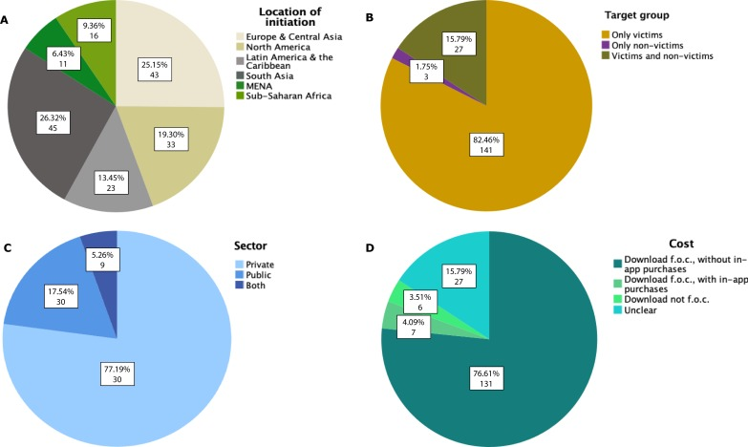

Significant limitations to reducing violence against women might be found in light of our findings. According to this analysis, emergency applications for women who are (possible) victims of abuse made up the greatest share of all kinds of applications. This prevalence of emergency applications should be questioned since it shows that the current healthcare approach emphasizes individual, one-time solutions for isolated acts of violence.

**Acid and child marriage**

The Acid Survivors Trust International is a UK based not-for-profit organisation that exists solely to put an end to acid violence worldwide. ASTI was established in 2002, and since then, it has collaborated with a network of six local partners in Bangladesh, Cambodia, India, Nepal, Pakistan, and Uganda. In order to deliver medical, legal, awareness-raising, advocacy, rehabilitation, and livelihood programs in several countries, ASTI has collaborated with and received funding from the United Nations, the British Government, and numerous foundations. This organization paves the way for the holistic development of an attack survivor by giving them access to professional skills training and financial support, but there has been no mention of providing them direct employment by either partnering with NGOs or connecting them to employers.

In order to address child marriage in the 12 countries with the highest prevalence or burden, UNICEF and UNFPA established a global program in 2016 in Bangladesh, Burkina Faso, Ethiopia, Ghana, India, Mozambique, Nepal, Niger, Sierra Leone, Uganda, Yemen, and Zambia. This Global Program helps girls by bringing together important participants in the fields of gender, health, social change, education, child protection, and other areas. The programme engages communities and partners for more coordinated action and accountability while enhancing the capacities of governments and non-governmental organisations. Though many such and other organizations focus on eradicating child marriage by introducing various schemes for families with a poor socio-economic background, none of the ones we found actually tried to cater to the root cause of the problem at hand.

An app was created by the government of Bangladesh and Plan International to help marriage registrars confirm the real ages of the bride and groom. An SMS-based version could be used in places without the internet, which are frequently the most isolated rural areas (Unicef Bangladesh, 2018). The software uses a database from the government that contains kids' identity documents. The nation may have a better chance of preventing child marriage by concentrating on the 100,000 marriage registrants than by altering the thinking of the populace as a whole.

Particularly in Kenya, menstruating females miss 4.9 days of school on average per month, which may explain why just 37% of Kenyan girls finish secondary school compared to 46% of boys. Since only 35% of Kenyan women can independently buy sanitary pads, this issue is made worse by financial hurdles to access, particularly for low-income Kenyan women. In June 2017, the Kenyan government promised to give all schoolgirls in the country free sanitary pads in recognition of this imbalance.

The app, Hedhi Help, made use of the chance to create a culturally suitable Android-based menstruation education mobile application. The application was created with the intention of giving Kenyan girls the information, assistance, and tools they need to understand their menstrual cycles and bodies.

Babies are regularly born at home in Timor-rural Leste's communities because access to healthcare might be difficult. The Liga Inan initiative seeks to increase the probability that expectant mothers deliver their babies with a trained birth attendant. In order to increase the consumption of services including prenatal care, facility births, postnatal care, and immunization, tailored SMS messages are delivered to women based on their stage of pregnancy or motherhood.

To urge the father-to-be to actively support women and their newborn children by helping out around the house and providing childcare. Based on in-depth behavioral research, the message's content and delivery are intended to subtly encourage social change through individual behaviors and questioning presumptions.

**2.2** **National** **Status:** *(Maximum* *1* *page)*

*(Same* *as* *above* *to* *cover* *the* *contribution* *of* *Indian* *Scientists* *in* *the* *project* *area)*

There are several applications for women safety applications made in india. Some of them are:

Naari: 1k+ downloads: A Women Safety App, allows the user to create their own safety network and take care of themselves.Using this app women can send their real-time location to her relatives, guardian and friends along with an alert message when in danger.The distinctive attribute of this android application is that it sends SMS to the saved contacts until the power switch in the application is clicked. The main drawback in this type of application is that during the time of crisis, women wouldn't have the time to take out the phone and send the sos message to their near and dear ones.

Raksha: 5k+ downloads: This app comes with the following features: Safety Tips, Women's Laws, Self-Defense, SOS Alert. Also, in case of any unsafe situation, just tap the message button to raise an emergency SOS alert to the trusted contact selected by you. The SOS alert will be in the form of an SMS, informing them that you are unsafe and need help. Along-with, you can see nearby police stations on a Google Map based on your current GPS location with a feature to call them as well as get directions. The main drawback of this app is that it goes to the speed dial section of the phone during an emergency , indicating that it is not providing exact support but just working as a shortcut to other applications.

Several such applications are available in the market. All of them target mainly the SMS calling feature, which can be enabled by physically using the phone.

**ACID and Child marriage**

Though India is in the top 3 countries worldwide in terms of acid attack cases, only a little change and development has been recorded in terms of employment opportunities for the acid attack survivors, who are majorly women.

Make Love Not Scars, a non profit organization that was founded in 2014, majorly focuses on the rehabilitation of acid attack victims. It runs a rehabilitation facility in Delhi for victims of acid attacks and focuses on giving them access to rapid life-saving medical care, reconstructive surgery, legal support, and skill development to help them adjust to the profound changes. Though there are many activists who have worked in this domain and started various foundations, most of them only cater to the rehabilitation of the survivors, but the core issue of their financial independence remains intact. Even now, some companies have opened their doors to hiring the attack survivors because businesses do not want to hire people who seem different. Therefore, these survivors are unable to find employment.

Even in this day and age, they face discrimination based on appearance. Many people even struggle to make ends meet, pay their rent, or send their children to school. Even if there are innumerable articles, tweets, likes, and shares on social media praising their bravery, they don't have a single basic job that would pay them enough to live with dignity while having the complete moral backing of society.

In order to track the attendance of schoolgirls in Malda, West Bengal, UNICEF and the Administrative Staff College of India have collaborated to develop an app. The app aims to monitor girls' attendance and sound an alarm in the event of an abnormality.

The Indian government has also launched many schemes like the Dhanalakshmi scheme, which is aimed at encouraging parents to educate their children by offering them an alluring insurance plan and covering some of the costs associated with caring for newborn girls in an effort to end child marriage, and many more.

On International Women's Day 2019, the Naubat Baja project was launched with the goal of reducing child marriages in Rajasthan and empowering females through mobile technology. The initiative was started by the United Nations Population Fund (UNFPA) in partnership with the Rajasthani government, the Directorate of Women's Empowerment, and the Rural Electrification Corporation (REC) Foundation. Girls in Rajasthan who contact the Naubat Baja number get a call back with a recording about government welfare programmes, employment prospects, information about child marriage, health, and hygiene, COVID-19 protocols, and other pertinent topics. Much of this knowledge is communicated in a variety of entertaining mediums, including songs, short stories, and audio dramas, which Naubat Baja regularly updates. Projects like the Naubat Baja project serve as examples of how mobile phones may empower girls by giving them access to empowering materials and information, thus combating child marriage and gender inequality.

Through a joint Global Programme to Accelerate Action to End Child Marriage, UNICEF and UNFPA have joined forces to address child marriage holistically. For the first time, bringing together existing strategies in areas like health, education, child protection, nutrition, and water and sanitation. The strategy is to address child marriage across a child's whole lifespan, particularly by addressing enduringly harmful social norms that are major contributors to the high occurrence of child marriage in India. The initiative employs strategies that have been shown to be effective at scale and collaborates with governments, civil society organizations, and young people themselves.

**2.3** **Importance** **of** **the** **proposed** **project** **in** **the** **context** **of** **current** **status** *(Maximum* *1* *page)*

(*Highlight* *what* *is* *the* *new* *area* *or* *gap* *which* *will* *be* *solved* *in* *the* *project relating* *to* *what* *is* *already* *known.* *This* *is* *a* *very* *important* *section* *to* *project* *the* *novelty* *content* *of* *the* *proposal*)

**2.4** **If** **the** **project** **is** **location** **specific, the** **basis** **for** **selection** **of** **location** **be** **highlighted**: *(Maximum* *1/2* *page)*

**3.** **Work** **Plan:**

**3.1** **Methodology**: *(Maximum* *of* *5* *pages)*

*(It* *should* *contain* *all* *the* *details* *of* *how* *each* *of* *the* *objectives* *will* *be* *addressed.* *This* *section* *must* *be* *detailed* *and* *have* *clear* *plans,* *not* *vague* *and* *generalized* *statements.* *It* *should* *have* *several* *schemes,* *tables,* *figures,* *equations* *etc.* *in* *addition* *to* *text,* *explanation* *and* *justification* *of* *why* *the* *project* *research* *plan* *will* *work)*

***Women safety***

The Internet has definitely helped us to connect, but unfortunately, it is also used for harassment. Physical crimes such as mugging, sexual assaults, etc are still prevalent in this modern world. Women and children are generally more susceptible to such violence. Thus, there is a need for an intelligent system to make the lives of people safer in both the digital and physical worlds. Our solution is an all in one solution that covers the detection and precaution of online and offline violence. It has been found that, in most cases, such incidents can be avoided if the victims were made aware of how to react to such situations. Appropriate action can be taken if the crimes are reported to the authorities immediately.

Naari-kavach aims to follow these objectives:

* Ensure women safety by detecting and preventing online as well as offline harassment
* Resolve the issue of private audio and text data being used outside the user’s device by implementing federated learning
* Detect abusive content and images received, determine which section of criminal offense it falls under and report to appropriate authorities
* Develop an algorithm to suggest an user-specific safest route from the source to the location using Bayesian network, clustering and appropriate graph/deep RL algorithm
* Implementation of an SOS function in which our app detects distress/fear in speech in real time and promptly notifies emergency contacts in the form of an alarm.

Use case diagram for a person using our app for women safety:

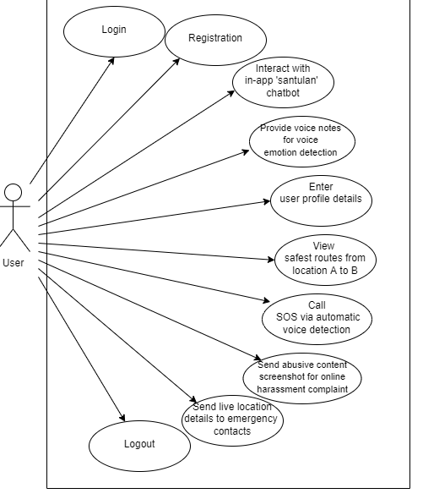

***Healthcare***

Women, especially in rural parts of India, need to understand the importance of their physical as well as mental well being. It is important to educate girls/ women of all ages about the importance of menstrual hygiene and about their basic rights regarding the same.

Naari kavach aims to follow these objectives:

* Interactive, multilingual in-app chatbot for understanding the various symptoms women of all ages go through in respect of menstruation as well as normal health.
* The in-app chatbot would provide various health articles for a healthy lifestyle and would include diet recommendations as well for women having any particular vitamin deficiency.
* During the time of emergencies, women ( especially pregnant women) may need immediate attention.

**3.2** **Time** **Schedule** **of** **activities** **giving** **milestones** **through** **BAR** **diagram.**

14-15 month

(Maximum 1 page)

**3.3** **Suggested** **Plan** **of** **action** **for** **utilization** **of** **research** **outcome** **expected** **from** **the** **project.** *(Maximum* *½* *page)*

**3.4** **Environmental** **impact** **assessment** **and** **risk** **analysis.** *(Maximum* *½* *page)*